Ubuntu Simulator - IT Troubleshooting Guide
Introduction
This document outlines common IT support issues simulated in a virtual machine environment along with the structured troubleshooting steps used to resolve them. The goal is to demonstrate problem-solving, technical understanding, and documentation skills relevant to entry-level IT support roles.

Environment
The scenarios in this report were performed using a virtual machine running Ubuntu Linux on a MacBook via UTM. The environment simulates common user and system-level issues found in typical IT support situations.

Troubleshooting Scenarios
Issue 1: User Unable to Log In
Problem: User was unable to log in correctly due to incorrect credentials.

Possible Causes:
- incorrect password
- user input error
Steps Taken
- switched to user differ user
- settings
- reset password for target user from administrator account
- logged in again

Resolution: User successfully logged into their account

Issue #2: File/Folder Access Restrictino
Problem: User was unable to access a folder due to restrictive permission settings.

Possible causes:
- access to user’s home directory was restricted due to settings
- folder permissions limited access to owner only.
Steps taken:
- Attempted to access folder from user account
- Verified access was restrictd
- Main user account right-clicked to review folder and directory permission settings
- Modified permissions from the main user’s Home area to allow file access to other users
- Retried access from test account

Resolution: Access successfully restored after updating user’s folder and directory permissions.
testuser POV:
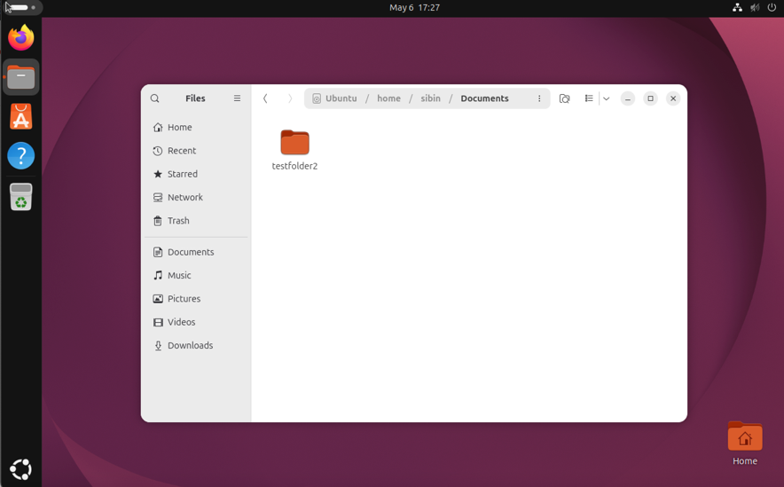

Issue #3: No Internet Connection
Problem: User unable to access webpage due to internet connection

Problem Causes:
- Network disabled
- System connectivity issue
Steps Taken:
- Attempted to access websites
- Verified lack of connectivity
- Checked network status
- Disabled, then Reenabled network connected after 1 minute
- Retested internet access and accessed web browser

Resolution: Internet connection restored after reset to enable the network

Skills demonstrated
Scenario 1 (Login Issue)
User account management
Authentication troubleshooting
Problem verification & testing
Root cause analysis
System Navigation

Scenario 2 (File Access Controls)
Directory-level permissions
File-level permissions
Troubleshooting access restrictions
Validation of permission changes

Scenario 3 (Wi-Fi Connection)
Issue verification
Basic network troubleshooting
System setting verifications
Validation of connectivity restoration

